Name: IRAKOZE CHRISTOPHE
Class: L3 SWD B
Date: 09/03/2026

Scenario 1:
Task 1.1: Screenshot of the newly created repository on GitHub Task
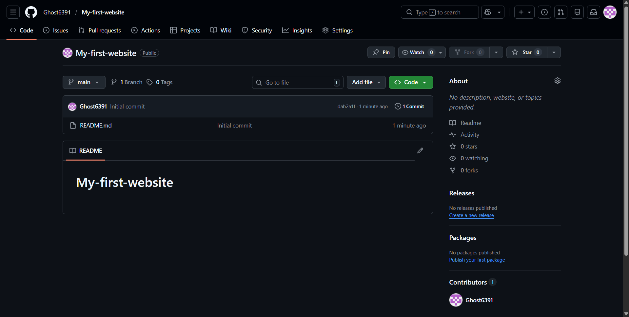
1.2 screenshot terminal configure git on machine
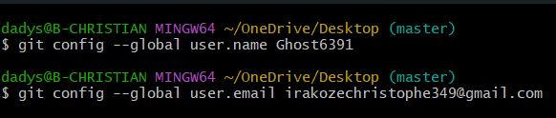

1.3: screenshot of terminal after cloning, and showing the output
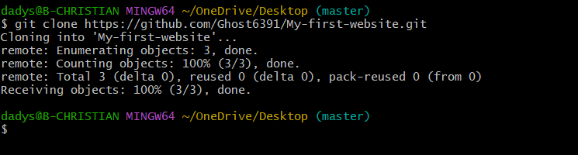
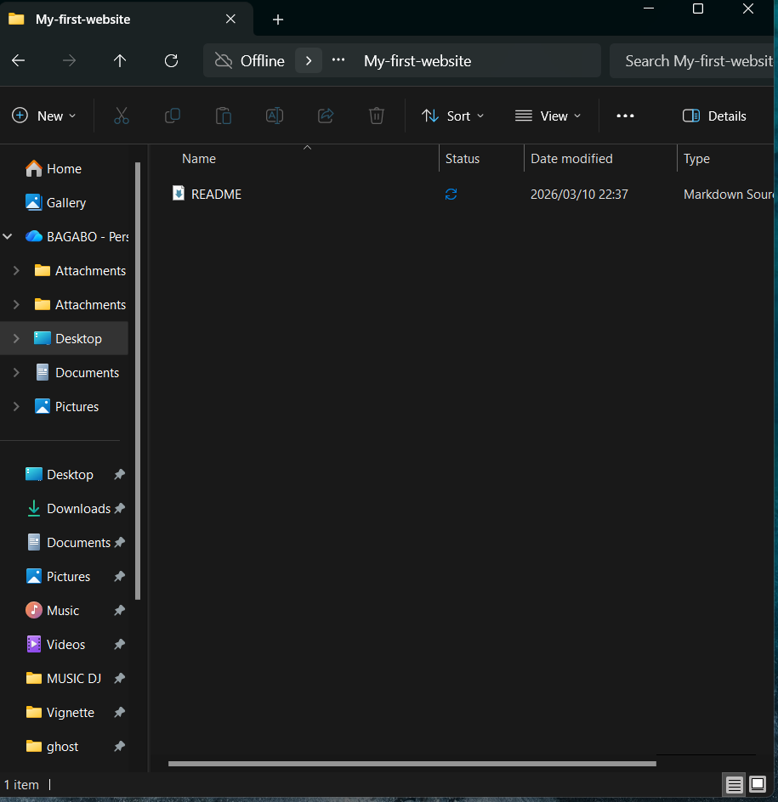

Task 1.5: Screenshot of terminal shows the staging, commit, and push steps
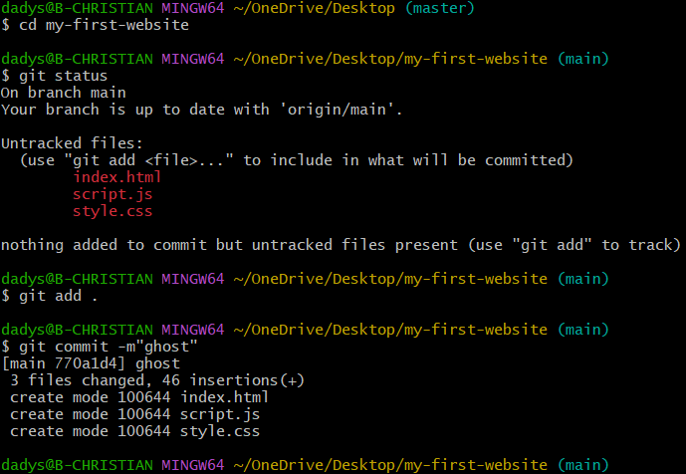
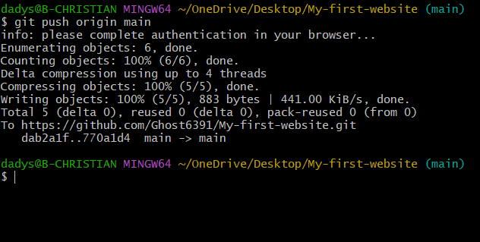

Screenshot of GitHub account repository page confirming both files are visible

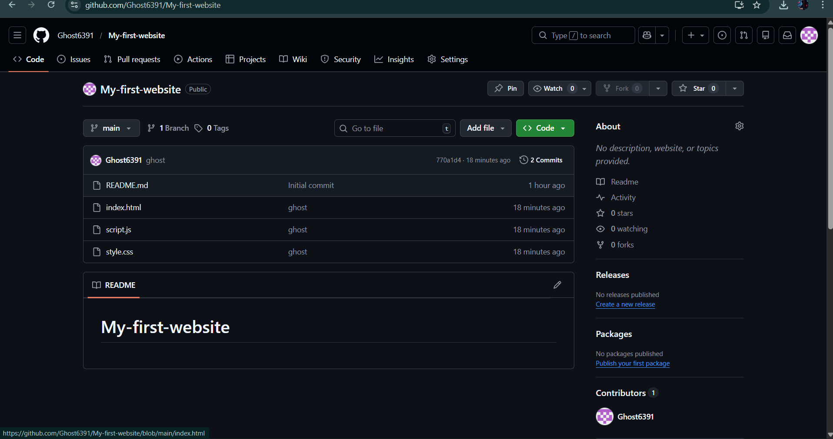
Scenario 2:
Task 2.1: Screenshot of terminal confirming the active branch is feature/contact-page.
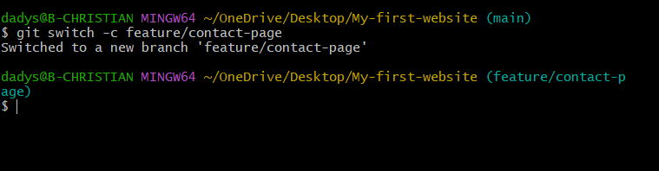

Task 2.4: Screenshot of terminal showing the push to the feature branching
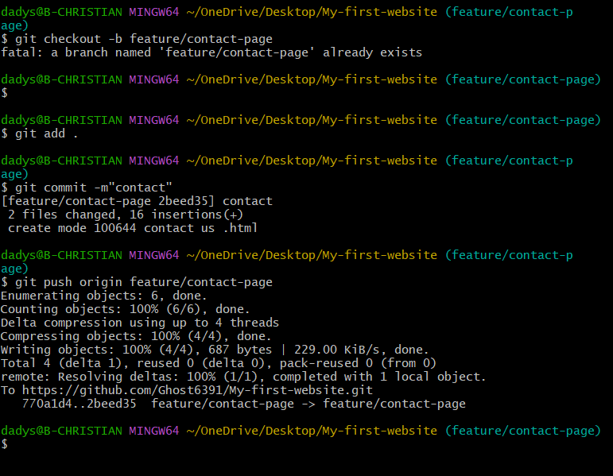
Screenshot of GitHub repository shows the feature/contact-page branch containing contact.html
